HTML

📘 Definition
# Source: AI Source: Provided by: [Data Path: Persons Table -> ID Column: 1, Name_En Column: Motasem Essam] -> From: [ChatGPT] on [5/6/2026]
HTML stands for HyperText Markup Language. It is the standard language used to create and structure content on web pages.
HTML is used to:
- Structure content (like text, images, and links)
- Tell the browser how to display content
- Build the foundation of every website
When you open any website, your browser (like Google Chrome or Mozilla Firefox) reads HTML code and shows it as a web page.

🧱 Basic Idea of HTML
# Source: AI Source: Provided by: [Data Path: Persons Table -> ID Column: 1, Name_En Column: Motasem Essam] -> From: [ChatGPT] on [5/6/2026]
HTML uses tags to organize content.
Example:
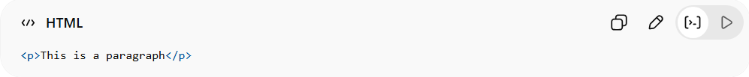
<p>This is a paragraph</p>
- <p> = opening tag
- </p> = closing tag
- The text inside = content

🏗️ Simple HTML Page Example
# Source: AI Source: Provided by: [Data Path: Persons Table -> ID Column: 1, Name_En Column: Motasem Essam] -> From: [ChatGPT] on [5/6/2026]
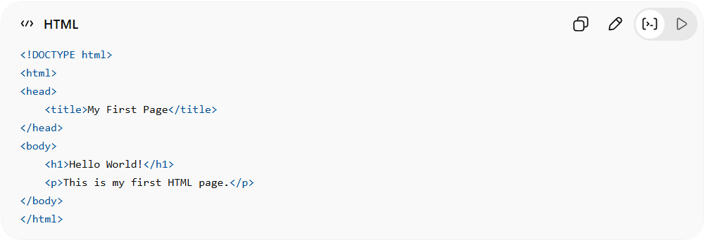
<!DOCTYPE html>
<html>
<head>
<title>My First Page</title>
</head>
<body>
<h1>Hello World!</h1>
<p>This is my first HTML page.</p>
</body>
</html>

🧩 Common HTML Editors
# Source: AI Source: Provided by: [Data Path: Persons Table -> ID Column: 1, Name_En Column: Motasem Essam] -> From: [ChatGPT] on [5/6/2026]
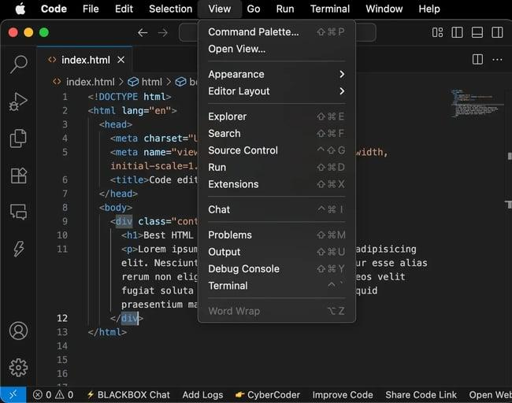
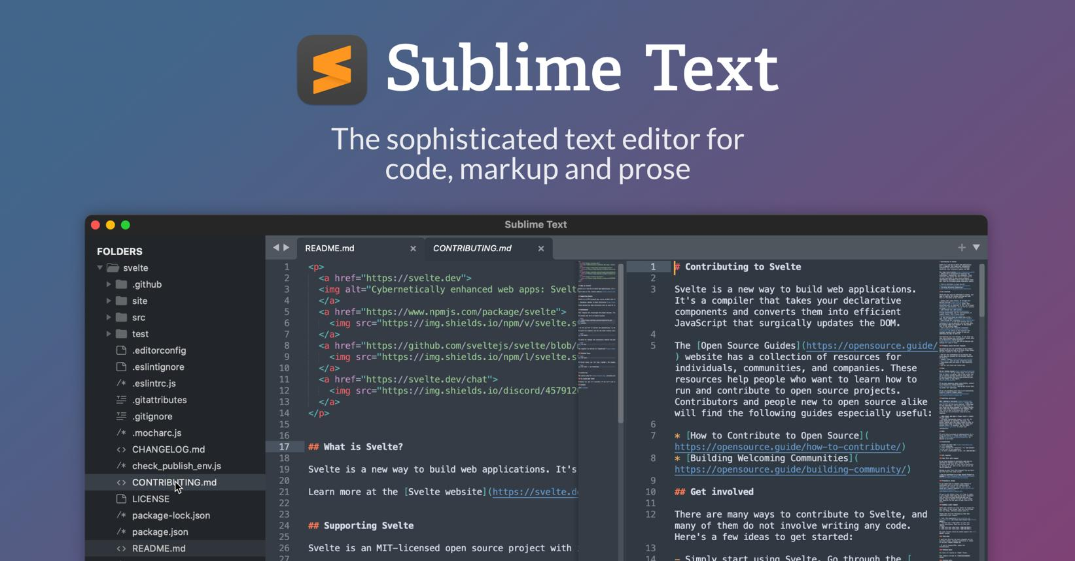
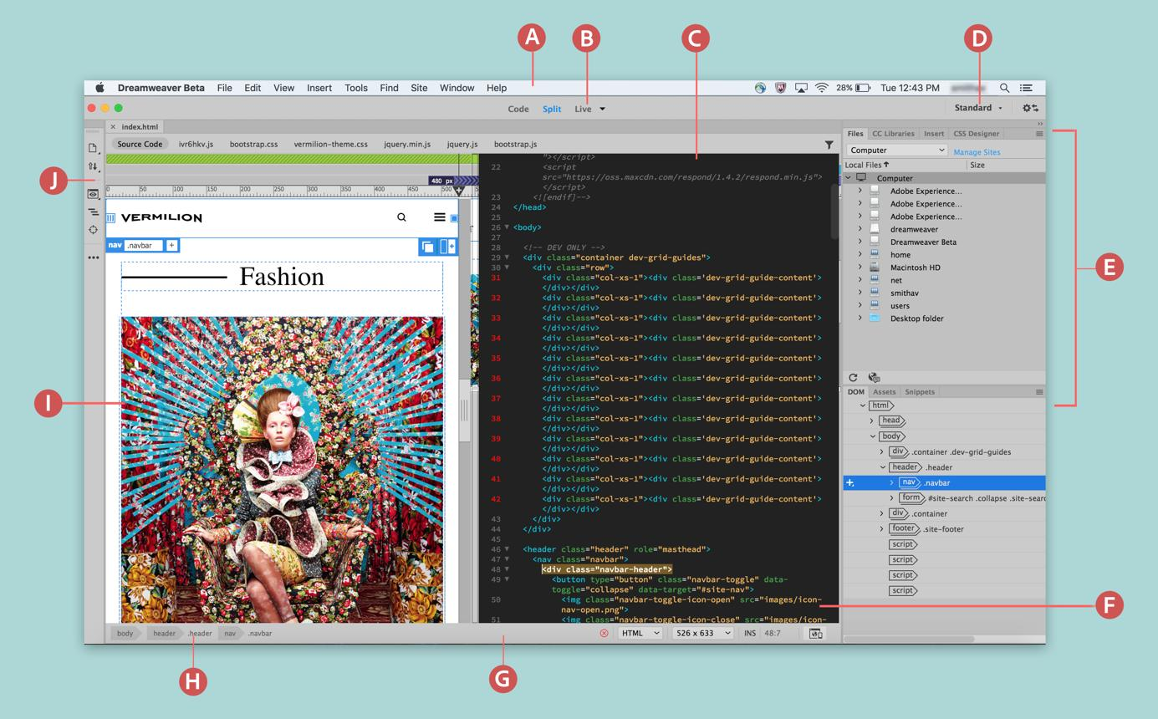

1. 🟦 Visual Studio Code (VS Code)
# Source: AI Source: Provided by: [Data Path: Persons Table -> ID Column: 1, Name_En Column: Motasem Essam] -> From: [ChatGPT] on [5/6/2026]
📖 Description
A modern and very popular code editor by Microsoft.
✅ Advantages
- Free and lightweight
- Huge extensions marketplace
- Excellent HTML/CSS/JS support
- Built-in terminal
- IntelliSense (smart suggestions)
- Git integration
❌ Disadvantages
- Can become slow with many extensions
- Requires setup for beginners

2. 🟪 Sublime Text
# Source: AI Source: Provided by: [Data Path: Persons Table -> ID Column: 1, Name_En Column: Motasem Essam] -> From: [ChatGPT] on [5/6/2026]
📖 Description
A fast and lightweight code editor.
✅ Advantages
- Very fast performance
- Clean interface
- Supports many programming languages
- Powerful shortcuts
❌ Disadvantages
- Paid license for full version
- Fewer built-in features than VS Code

3. 🟩 Notepad++
# Source: AI Source: Provided by: [Data Path: Persons Table -> ID Column: 1, Name_En Column: Motasem Essam] -> From: [ChatGPT] on [5/6/2026]
📖 Description
A simple text/code editor for Windows.
✅ Advantages
- Very lightweight
- Fast startup
- Beginner-friendly
- Free
❌ Disadvantages
- Windows only
- Old interface
- Limited advanced web tools

4. 🟨 Adobe Dreamweaver
# Source: AI Source: Provided by: [Data Path: Persons Table -> ID Column: 1, Name_En Column: Motasem Essam] -> From: [ChatGPT] on [5/6/2026]
📖 Description
A professional web design editor by Adobe.
✅ Advantages
- Visual drag-and-drop design
- Live preview
- Good for designers
- Supports responsive design
❌ Disadvantages
- Expensive subscription
- Heavy software
- Less popular today

5. 🟥 WebStorm
# Source: AI Source: Provided by: [Data Path: Persons Table -> ID Column: 1, Name_En Column: Motasem Essam] -> From: [ChatGPT] on [5/6/2026]
📖 Description
A professional IDE by JetBrains focused on web development.
✅ Advantages
- Advanced coding tools
- Excellent JavaScript support
- Smart debugging tools
- Powerful auto-completion
❌ Disadvantages
- Paid software
- Uses more system resources
- Can feel complex for beginners

6. 🟧 Brackets
# Source: AI Source: Provided by: [Data Path: Persons Table -> ID Column: 1, Name_En Column: Motasem Essam] -> From: [ChatGPT] on [5/6/2026]
📖 Description
An editor designed specifically for web development.
✅ Advantages
- Live preview feature
- Simple interface
- Good for HTML/CSS beginners
❌ Disadvantages
- Slower development/support today
- Fewer features compared to VS Code

7. ⚫ Vim
# Source: AI Source: Provided by: [Data Path: Persons Table -> ID Column: 1, Name_En Column: Motasem Essam] -> From: [ChatGPT] on [5/6/2026]
📖 Description
A highly customizable terminal-based editor.
✅ Advantages
- Extremely fast
- Powerful keyboard shortcuts
- Lightweight
❌ Disadvantages
- Very difficult for beginners
- Steep learning curve

⚖️ Quick Comparison Table
# Source: AI Source: Provided by: [Data Path: Persons Table -> ID Column: 1, Name_En Column: Motasem Essam] -> From: [ChatGPT] on [5/6/2026]
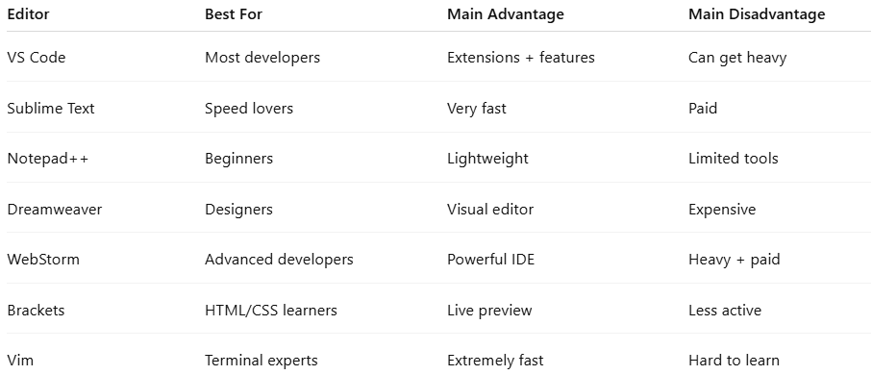
Editor | Best For | Main Advantage | Main Disadvantage
VS Code | Most developers | Extensions + features | Can get heavy
Sublime Text | Speed lovers | Very fast | Paid
Notepad++ | Beginners | Lightweight | Limited tools
Dreamweaver | Designers | Visual editor | Expensive
WebStorm | Advanced developers | Powerful IDE | Heavy + paid
Brackets | HTML/CSS learners | Live preview | Less active
Vim | Terminal experts | Extremely fast | Hard to learn

🚀 Best Practice Recommendation
# Source: AI Source: Provided by: [Data Path: Persons Table -> ID Column: 1, Name_En Column: Motasem Essam] -> From: [ChatGPT] on [5/6/2026]
- 🟢 Beginners → VS Code or Notepad++
- 🟢 Professional web development → VS Code
- 🟢 Advanced JavaScript projects → WebStorm
- 🟢 Visual web design → Dreamweaver

🚀 In short:
# Source: AI Source: Provided by: [Data Path: Persons Table -> ID Column: 1, Name_En Column: Motasem Essam] -> From: [ChatGPT] on [5/6/2026]
HTML = the structure of a webpage (the skeleton of a website).

